Panzer Meyer
5
MILITARY

1ST CAN
AIR POWER
Jabos +1 1 CAN
RESOURCES
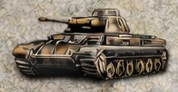
2nd Pz

ORDERS: 2 Actions
-1 Defense Strength Brit 2nd Army
Kurt Meyer, nicknamed "Panzermeyer" was commanding general of the 12th SS Panzer Division Hitlerjugend he regularly visited the front lines on a motorcycle. He sustained eighteen broken bones and four concussions during his career, testament to his daredevil personality.

